Part A: Conceptual Foundation (Theory)
Regularization, Cross-Validation & Tree-Based Models
1. What is Regularization in Machine Learning? Why is it needed?
Regularization is a technique that adds a penalty to the model's loss function to reduce model complexity. It helps prevent overfitting, improves generalization, and makes the model perform better on unseen data.
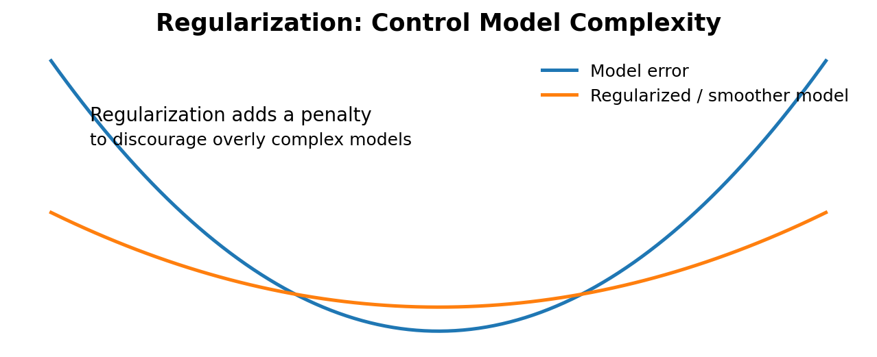
2. Difference between Ridge Regression (L2) and Lasso Regression (L1).
Ridge uses an L2 penalty (sum of squared coefficients), so it shrinks coefficients toward zero. Lasso uses an L1 penalty (sum of absolute coefficients) and can make some coefficients exactly zero, which also helps in feature selection.
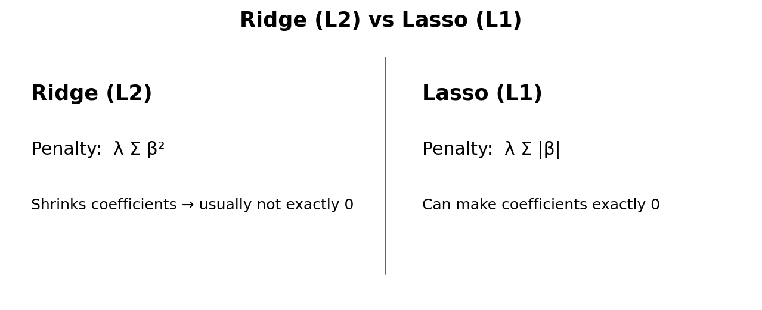
3. What is Cross-Validation and why is it important?
Cross-Validation divides the dataset into multiple parts and repeatedly trains and validates the model on different parts. It gives a more reliable estimate of model performance and helps detect overfitting before using the model on new data.
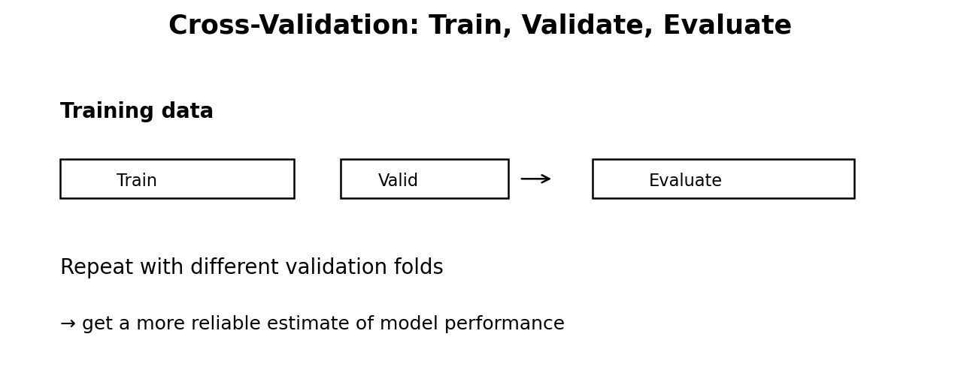
4. Explain the following cross-validation techniques:
• K-Fold Cross-Validation: The data is divided into K folds; each fold is used once for validation while the remaining folds are used for training.
• Stratified K-Fold: Similar to K-Fold, but it keeps the same class proportion in each fold, so it is useful for classification.
• Leave-One-Out Cross-Validation (LOOCV): One observation is used for validation and all remaining observations are used for training; this is repeated for every observation.
• Time Series Split: Training uses past observations and validation uses later observations. It avoids using future data to predict the past.
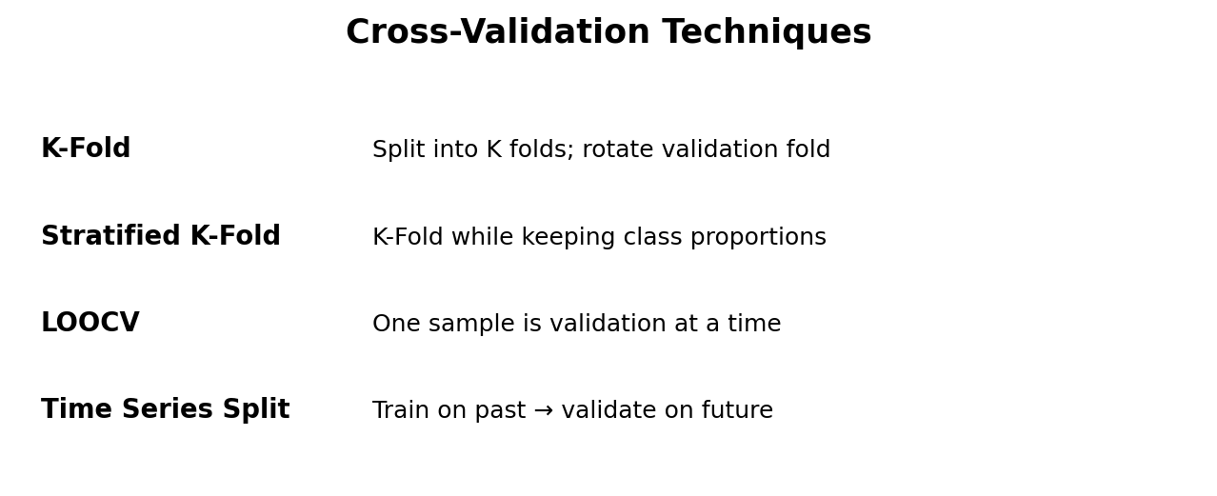
5. Why are tree-based models less sensitive to feature scaling?
Tree-based models make decisions using feature thresholds, such as 'Age ≤ 30', rather than distance or coefficient size. Therefore, changing the scale of a feature usually does not change the ordering of values or the useful split, so scaling is generally unnecessary.
